# More exercises: CSS Formatting and Positioning

Problems for exercises and homework for the ["HTML and CSS" course @ SoftUni](https://softuni.bg/courses/web-fundamentals-html5). Submit your solutions in the SoftUni judge system at <https://judge.softuni.bg/Contests/802/CSS-Formatting-and-Positioning>-More-Exercises.

## Pricing List

Create a Web page (HTML5 + CSS3 + images) that looks and behaves like the screenshots below:

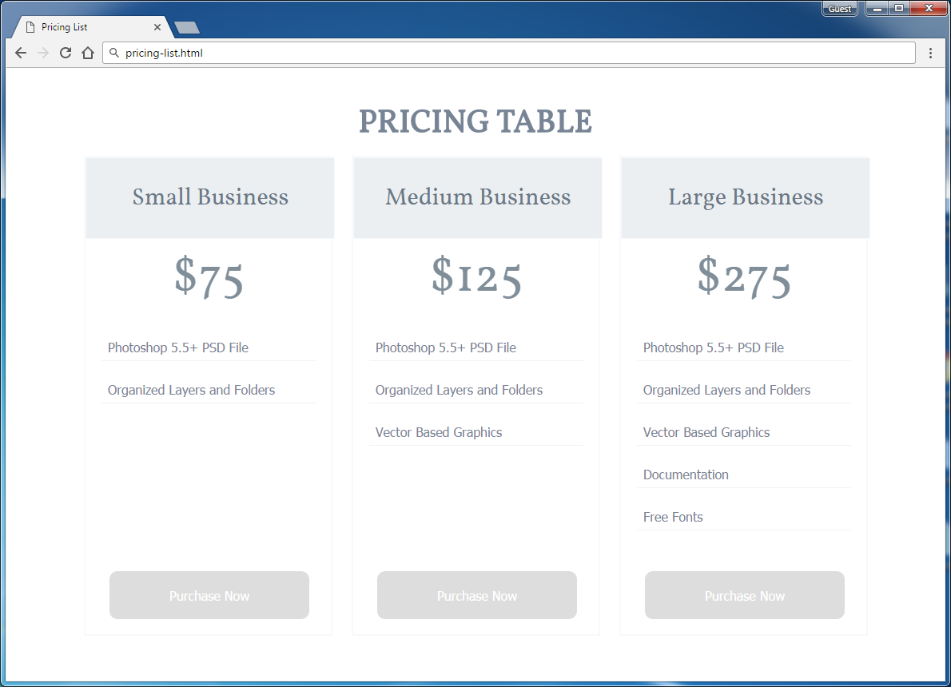

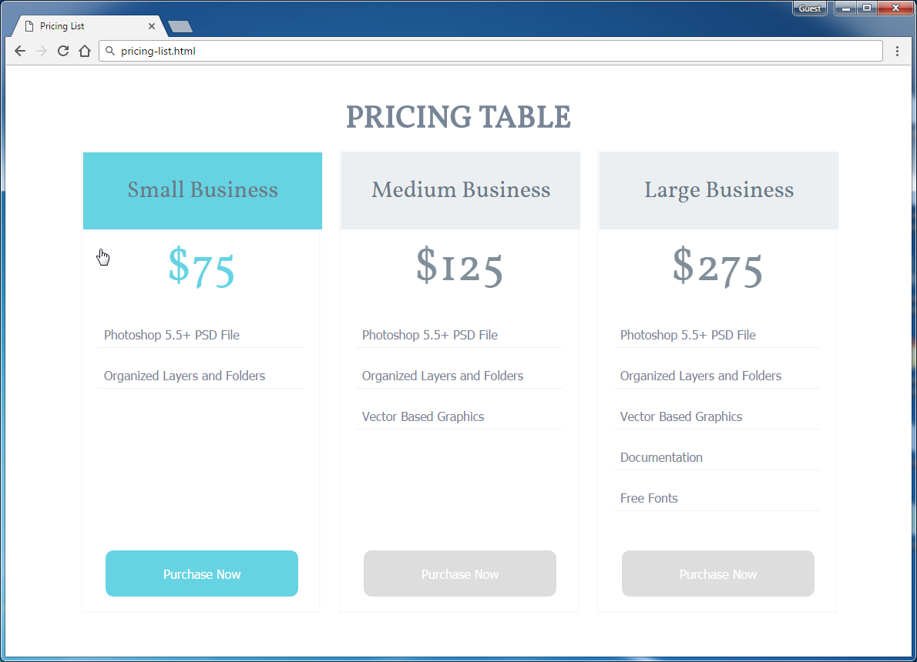

* The mouse hand-pointers and the bottom bar in the screenshots are not part of your page, so please skip them.

### Input

You are given the above screenshots + the images for the above three news items + the texts on the site.

### Output

The output should be valid HTML5 + CSS3 + images that implement the above Web page.

### Constraints

* The layout should be 1000px.
* Use google font **Vollkorn** - <https://www.google.com/fonts#UsePlace:use/Collection:Vollkorn>
* 'Vollkorn', serif; (size: 40px for the title, 30px for the subtitle, 60px for the price).
* Font: 16px Tahoma, sans-serif for the main text.
* **Button** for Purchase now
* There are 3 articles.
* Pixel-perfect implementation is not required.

## BBC News

Create a Web page (HTML5 + CSS3 + images) that looks and behaves like the screenshots below:

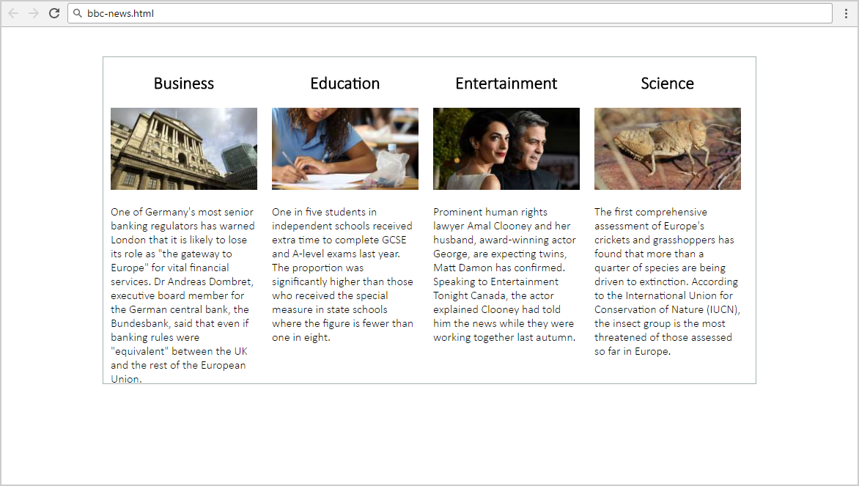

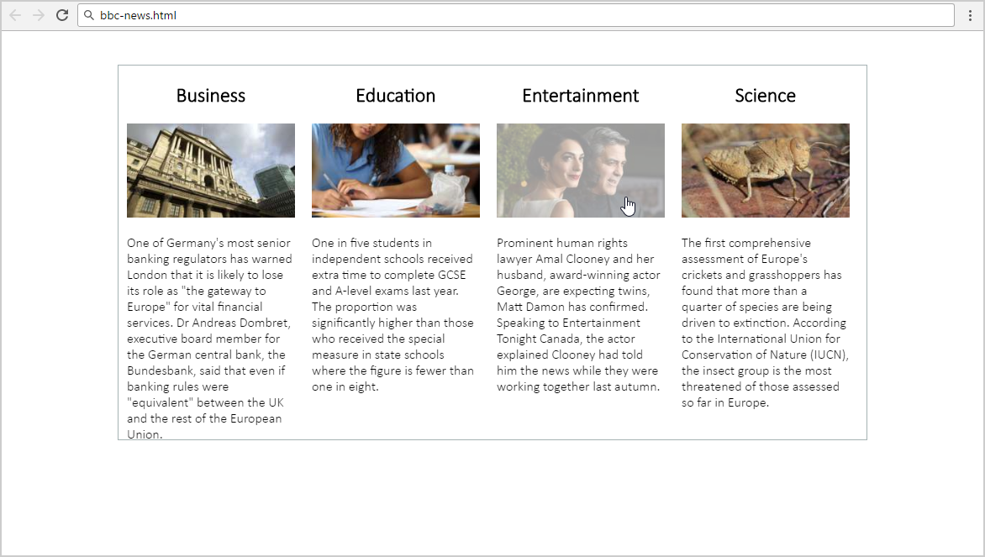

* The mouse hand-pointers and the bottom bar in the screenshots are not part of your page, so please skip them.

### Input

You are given the above screenshots + the images for the above four news items + the texts on the site.

### Output

The output should be valid HTML5 + CSS3 + images that implement the above Web page.

### Constraints

* The layout is body-centered and should be 890px.
* Font: Calibri Light / Verdana / sans-serif.
* Border color: #a5b2b3;
* There are 4 articles with image fully linkable and hover effect is transparency **0.4** of all the images.
* Pixel-perfect implementation is not required.

## IT News

Create a Web page (HTML5 + CSS3 + images) that looks and behaves like the screenshots below:

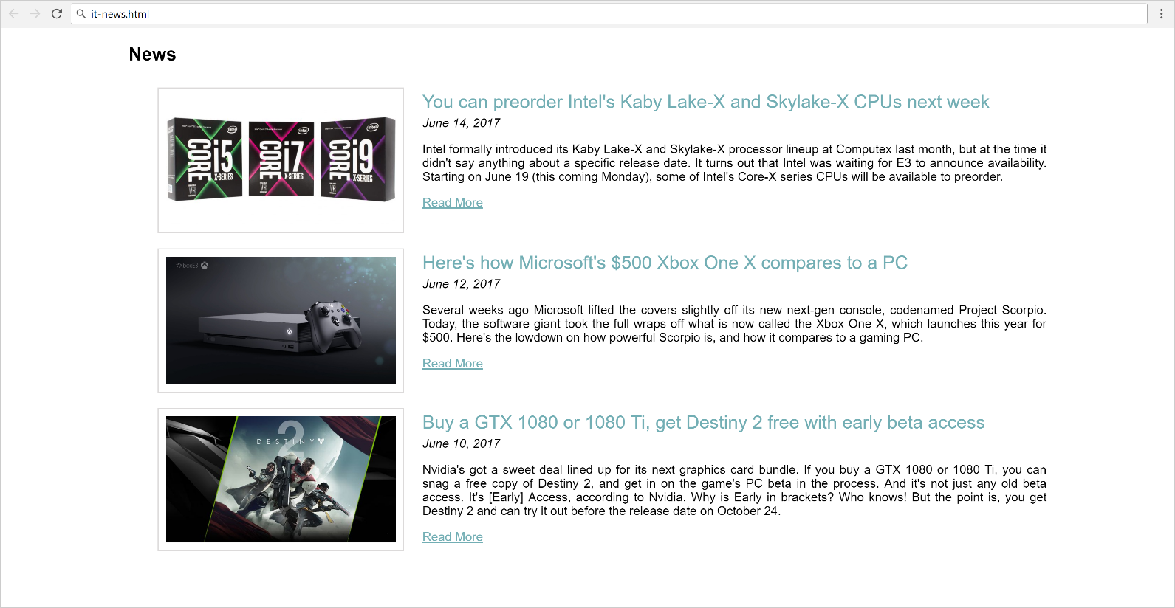

### Input

You are given the above screenshots + the images for the news items + the texts on the site.

### Output

The output should be valid HTML5 + CSS3 + images that implement the above Web page.

### Constraints

* The layout is body-centered and should be 1200px.
* Use google font **Vollkorn** - <https://www.google.com/fonts#UsePlace:use/Collection:Vollkorn>
* Text color: #72aeb4**;**
* There are 3 articles.
* Pixel-perfect implementation is not required.

## Watch Store

Create a Web site (HTML5 + CSS3) that looks and behaves like the screenshots below:

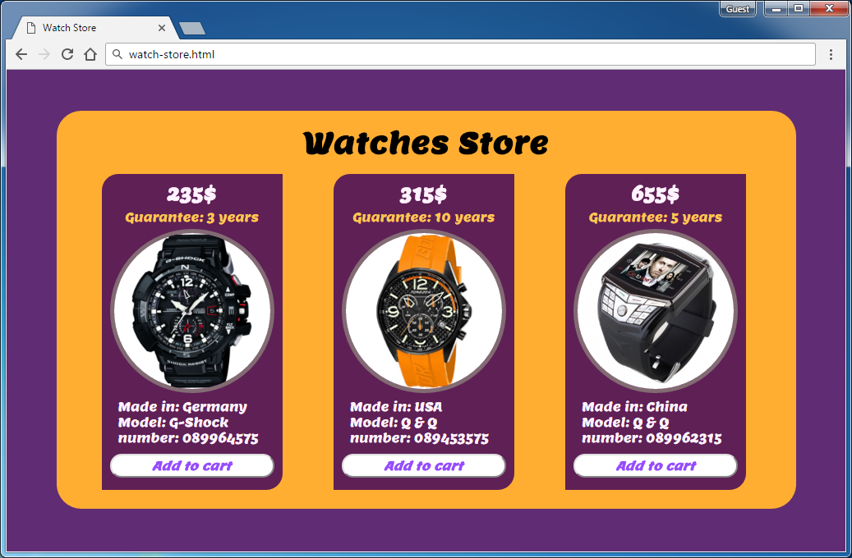

### Input

You are given the above screenshots + the required font + all required images + the texts on the site.

### Output

The output should be valid HTML5 + CSS3 that implement the above Web site.

### Constraints

* Font: Lemon-Regular / Arial
* Font size: **24px** for the main title, **22px** for price of watches, **15px** for info of the watches, **15px** for the buttons.
* Watches container width: 900px.
* Columns width: 220px.
* There are 3 articles
* Responsive design is not required.

## Zora Properties

Create a Web page (HTML5 + CSS3 + images) that looks and behaves like the screenshots below:

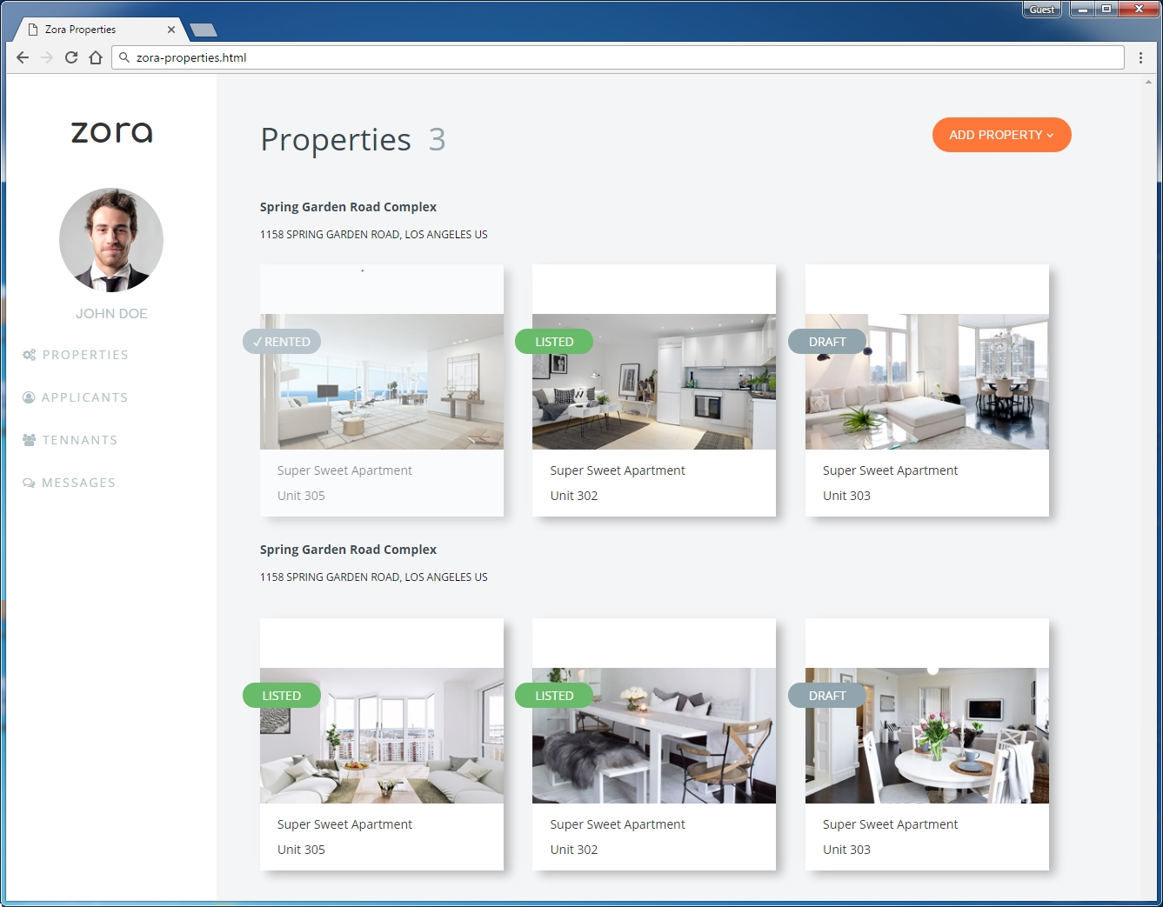

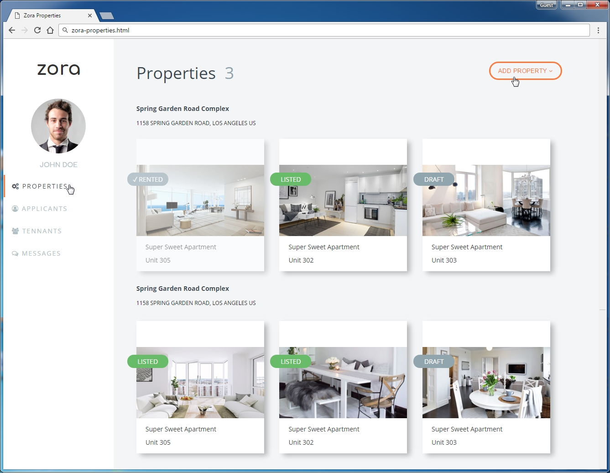

* The mouse cursors in the above screenshots explain what happens when the mouse moves over a project

### Input

You are given the above screenshots + all required images + the texts on the site.

### Output

The output should be valid HTML5 + CSS3 + images that implement the above Web page.

### Constraints

* Font: 14px "Open Sans", Arial, sans-serif; "Comfortaa", sans-serif
* Background Colors: #f3f5f7; #ff7739; #91a5af; #68bc69;
* Colors: #b1bfc6; #333; #384850; #ff7739; #91a5af;
* Pixel-perfect implementation is not required.

### Hints

For the site content structure you may use:

* Left side (sidebar): <aside> + <nav> + <ul>
  + Use left floating
* Right part (main content): <main>, <div>, <p>, <img>, <section>, <h1> to <h6>
  + Use margin-left to move the right part at its correct place

Use the following **font**, **styles** and **CSS definitions** for the left sidebar links with icons and for the orange button on the right:

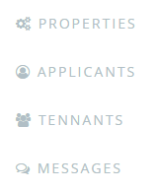 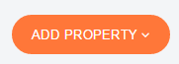

* @import url('<https://fonts.googleapis.com/css?family=Comfortaa:700|Open+Sans:400,700>');
* @import url('<https://maxcdn.bootstrapcdn.com/font-awesome/4.7.0/css/font-awesome.min.css>');
* <i class="fa fa-cogs" aria-hidden="true"></i>
* <i class="fa fa-user-circle-o" aria-hidden="true"></i>
* <i class="fa fa-users" aria-hidden="true"></i>
* <i class="fa fa-comments-o" aria-hidden="true"></i>
* <i class="fa fa-angle-down" aria-hidden="true"></i>

For the **property listings** you may use:

* Box Shadow: 8px 6px 17px -1px rgba(0,0,0,0.26);

For the **property labels**, use relative positioning:

 

For the **checkmark** character (✓) use the following HTML entity: &check;